Project Design Phase-II
Technology Stack (Architecture & Stack)

Date | 16 Feb 2026
Team ID | LTVIP2026TMIDS36006
Project Name | Asset Management Portal
Mentor Name | Dr Shaik Salma Begum
Maximum Marks | 4 Marks

Technical Architecture:
The Deliverable shall include the architectural diagram as below and the information as per the table1 & table 2

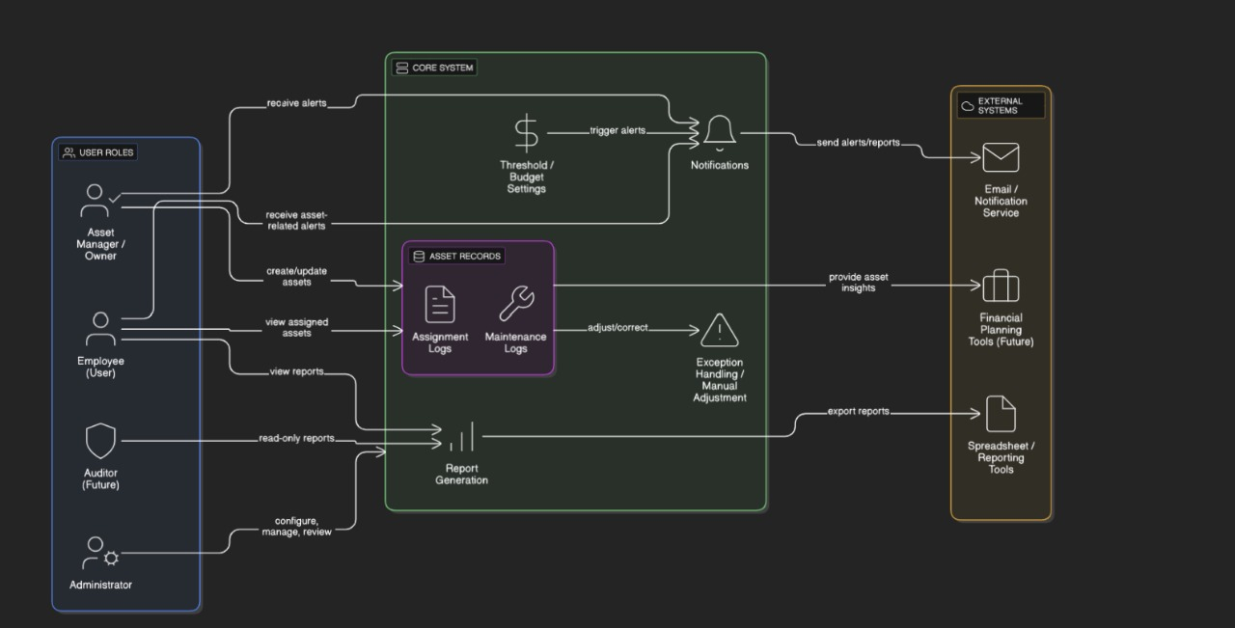
Table-1 : Components & Technologies:
S.No | Component | Description | Technology
1. | User Interface | Web-based forms and dashboards for asset tracking and management | ServiceNow UI Framework (Form Designer, Lists, Service Portal)
2. | Application Logic – 1 | Dynamic form behavior, field visibility, validation rules | ServiceNow Client Scripts, UI Policies (JavaScript, GlideForm API)
3. | Application Logic – 2 | Automation of asset lifecycle events like assignment, updates, and disposal | ServiceNow Flow Designer / Workflow Engine
4. | Application Logic – 3 | Alerts and email notifications for maintenance, audits, or disposal schedules | ServiceNow Notification Engine
5. | Database | Stores asset records, users, departments, conditions, and history | ServiceNow Custom Tables (Assets, Users, Requests, Logs), MySQL Backend
6. | External API – 1 | Integration with procurement, maintenance systems, or audit tools | ServiceNow REST API
7. | Infrastructure (Cloud) | Hosted on cloud platform with secure, scalable, and compliant environment | ServiceNow SaaS Cloud Infrastructure

Table-2: Application Characteristics:
S.No | Characteristic | Description | Technology
1. | Open-Source Frameworks | Uses JavaScript for form logic; can extend with AngularJS or React for advanced customization | JavaScript, AngularJS (optional), ReactJS (optional)
2. | Security Implementations | Role-based access (Admin, Asset Manager, Employee), secure endpoints | ServiceNow ACLs, HTTPS, TLS, Role-based IAM
3. | Scalable Architecture | Cloud-based, modular design; supports expanding asset types, rules, or workflows | ServiceNow Cloud Platform, REST APIs
4. | Availability | High uptime ensured via ServiceNow’s redundant and fault-tolerant infrastructure | ServiceNow SaaS with HA infrastructure
5. | Performance | Optimized record processing and caching, load-balanced delivery of static/dynamic resources | ServiceNow Caching, Akamai CDN or equivalent

